Ravan Muradzada
- Of course, first we need to mount the disk: `mount /dev/sr0 /mnt/`. Then we can create repositories:
First, we go to `/etc/yum.repos.d` and create two files there named `BaseOS.repo` and `AppStream.repo`.
For `BaseOS.repo`:
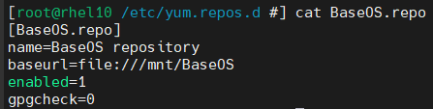

For `AppStream.repo`:
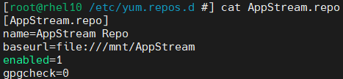

I swear, I did not copy it from anywhere ☺

- I can show some steps to check deeply whether the repo is working properly or not:
- ll /mnt/ - To check whether we mount the disk successfully or not.
- ll /etc/yum.repos.d - To check whether we create repositories successfully or not.
- cat /etc/yum.repos.d/<REPO_NAME>.repo - To see whether we add all mandatory fields successfully or not.
- yum repolist - It is a yum command to see all repositories. However, it is not always reliable, so the previous stages might be better.
- yum update - It is also a good step to check. If update process is not successful, there is a problem.

- We can run this command:
From the internet, I have found a better way to determine it:
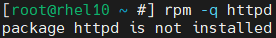

- Currently `httpd` is not installed in my system. So firstly, I will install it:
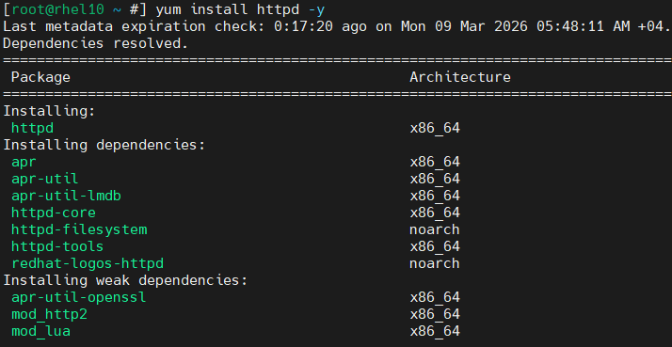

After installing it, I remove it:
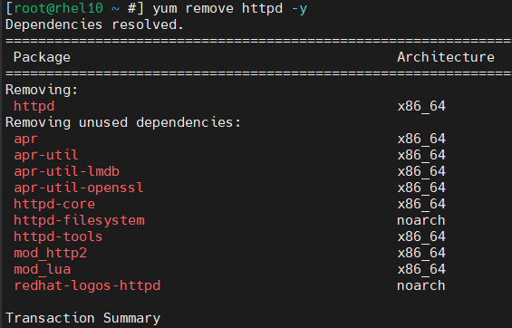
So, our commands for these processes are:
`yum install httpd -y`
`yum remove httpd -y`
(It is in my local repository, no worry)

- We can use either `yum search <PACKAGE_NAME>` or `yum whatprovides <PACKAGE_NAME>` in that kind of case. However, `whatprovides` option is better, because it searches much deeper than the `search` one.
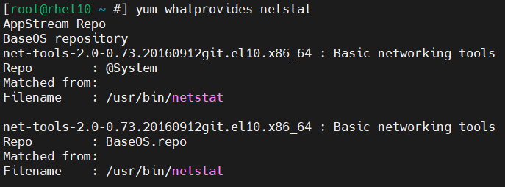

- After some research I found that we need to use `--hidden` option to get that. With the option, we get all groups including hidden ones:
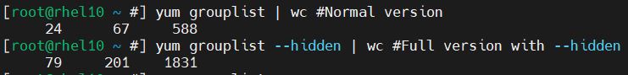

- First, I searched for this group to find its full name:

Now it is time to install this group:
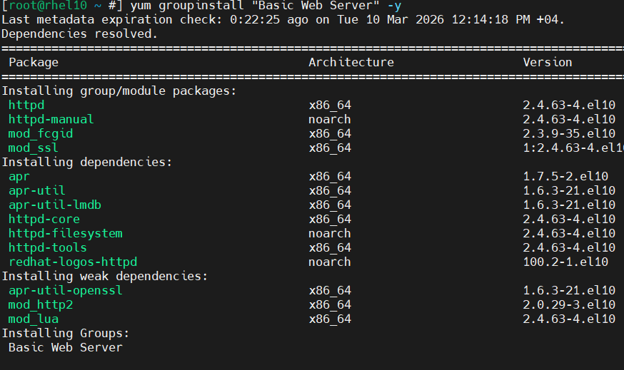
(No need to show all installation process)

- We can visit docker official website to reach information about its installation process. So, in the first step we need to remove some packages from the system to be able to download docker successfully.
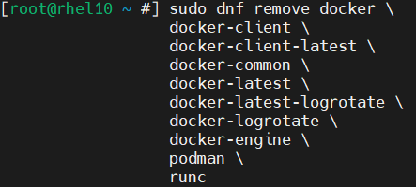
`yum` might report that you have none of these packages installed.

Now it is time to add docker repo to /etc/yum.repos.d/:
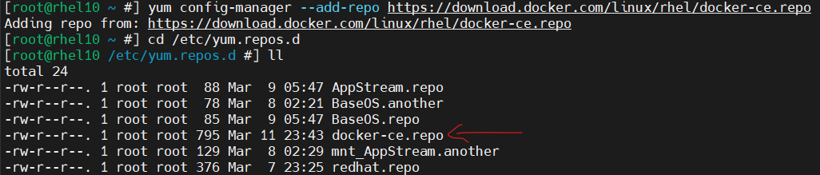

We can use `cat` command to its contents:
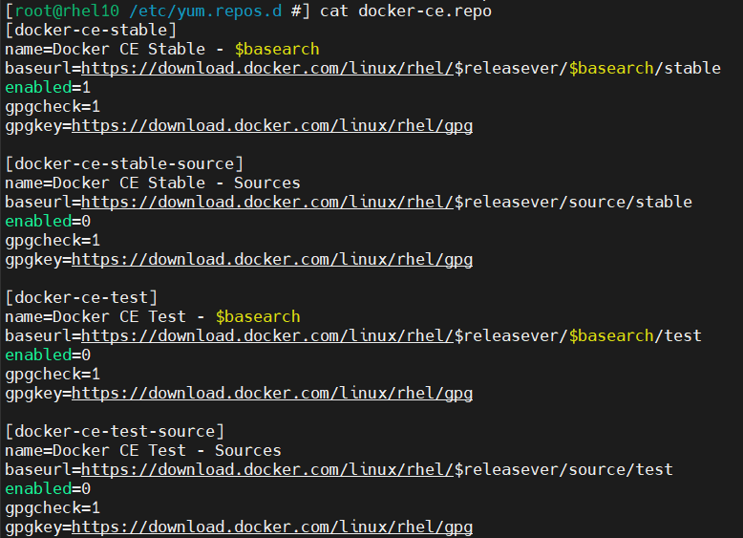
As you can see, it has added four sources for docker, but just one of them is enabled by default.

Now we can install the packages:
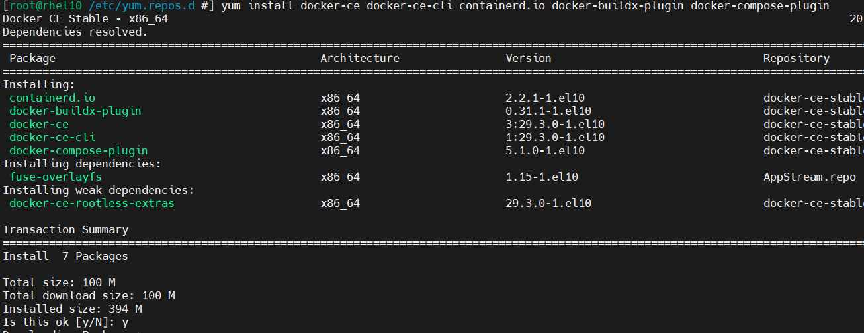
(I do not show full installation process, because it is very long)
Now for fun, we can enable docker service and pull one image from there:
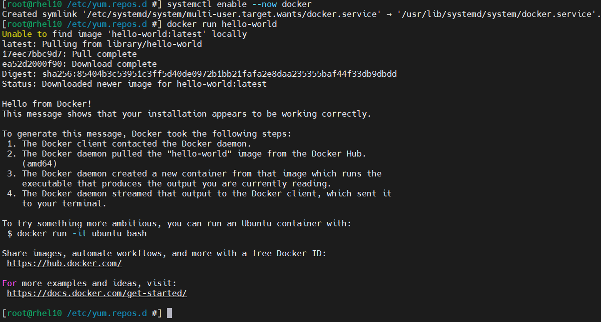

- If you wanted me to remove the docker packages, I just need to run this command:
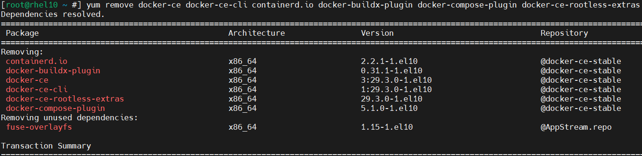

Then just run:

If you want to remove docker repository, too:

There is another way to remove installed packages. So, we can use `dnf history` command and it shows last dnf usages. Each usage has its own id. By using the id, we can run `dnf history undo <ID>`. Now the installed packages in process with this id will be removed now:
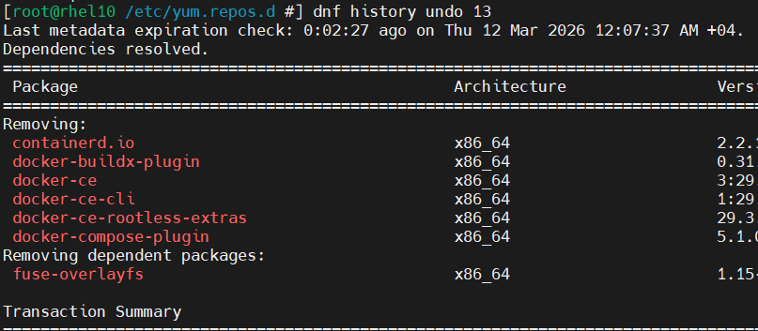

10) We should explain to the system that whenever we run proper command to install any package (like `yum install nano`), it should search it from this specific directory (mountpoint).
When we run yum command, it does not search for the full system, it comes to repositories and find the proper locations from here. The directory to put the repositories in is `/etc/yum.repos.d`.
We create a file here, a repository with the extension of .repo for package directories like AppStream or BaseOS.

11) A dependency is a package/software that another package requires to function.
Dependency hell is when managing dependencies becomes very difficult and exhausting due to conflicts, chains, or version mismatches.

